**Exercise 4: Financial Forecasting**

**Scenario:**

You are developing a financial forecasting tool that predicts future values based on past data.

**Steps:**

1. **Understand Recursive Algorithms:**
   * Explain the concept of recursion and how it can simplify certain problems.
2. **Setup:**
   * Create a method to calculate the future value using a recursive approach.
3. **Implementation:**
   * Implement a recursive algorithm to predict future values based on past growth rates.
4. **Analysis:**
   * Discuss the time complexity of your recursive algorithm.
   * Explain how to optimize the recursive solution to avoid excessive computation.

### 1. Understand Recursive Algorithms:

#### What is Recursion?

* **Recursion** is when a method **calls itself** with smaller inputs until reaching a **base case**.
* It simplifies problems that can be broken into smaller versions of the same problem.

#### Why is recursion useful here?

* Financial projections often follow a pattern:

futureValue(year) = futureValue(year-1) * (1 + growthRate)

* Instead of using loops, recursion lets us directly state the math:

**“Future value at year depends on the value of year-1”**

### Setup:

### Create a method:

double calculateFutureValue(double presentValue, double growthRate, int years)

**Present Value**: Starting amount.

**growthRate**: Yearly rate (e.g. 0.05 for 5%).

**years**: Time horizon.

1. **Implementation:**

**Financial Forecasting.java**

public class FinancialForecasting {

public static double calculateFutureValue(double presentValue, double growthRate, int years) {

if (years == 0) {

return presentValue;

}

return calculateFutureValue(presentValue, growthRate, years - 1) * (1 + growthRate);

}

public static void main(String[] args) {

double presentValue = 1000.0;

double growthRate = 0.05;

int years = 10;

double futureValue = calculateFutureValue(presentValue, growthRate, years);

System.out.println("Future Value after " + years + " years: $" + futureValue);

}

}

**OUTPUT:**

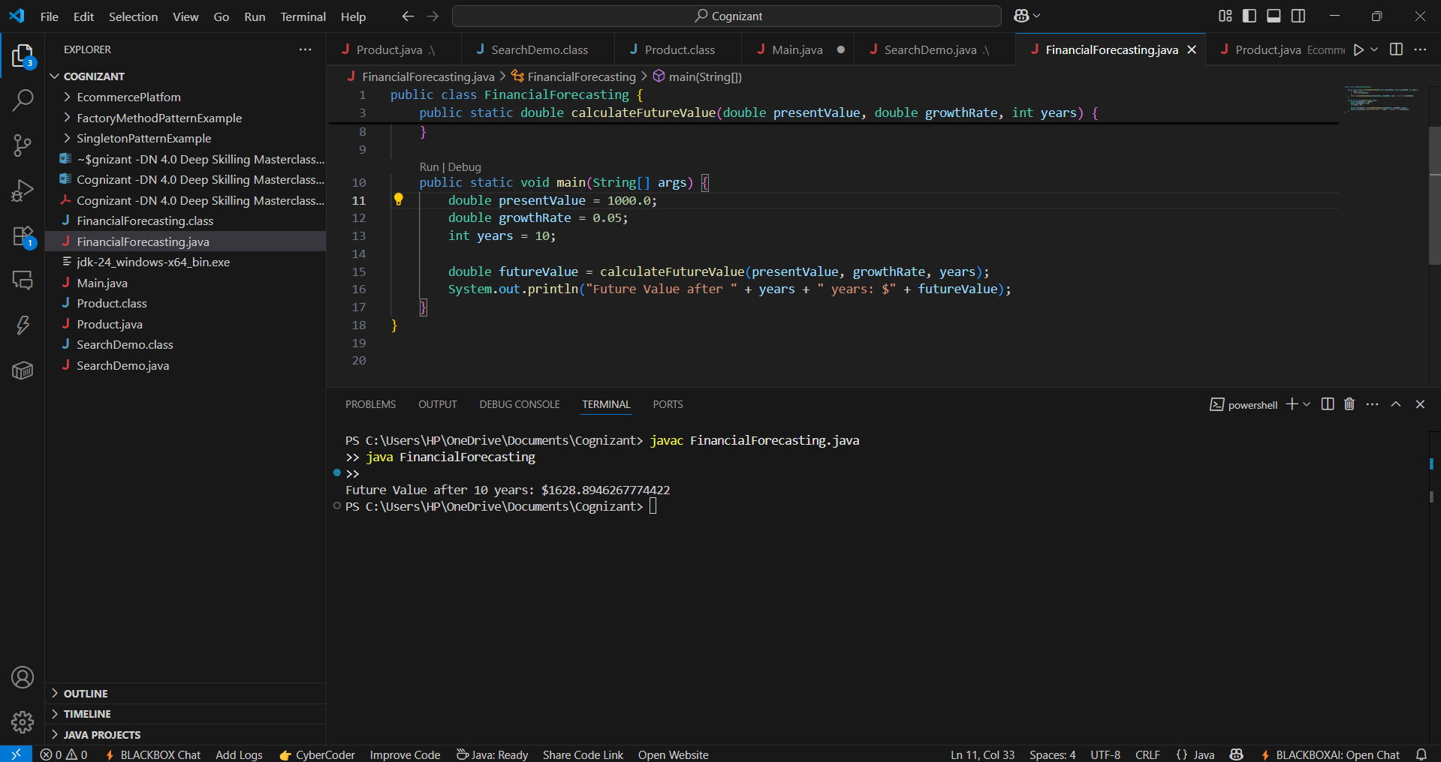

### 4. Analysis:

#### Time Complexity

**Recursive call depth** = years.

Time complexity = **O(years)** because the method is invoked once per year.

Space complexity = **O(years)** due to the recursive call stack.

#### Optimize:

#### ****Iterative Approach****

Replace recursion with a simple for loop to save stack space:

double value = presentValue;for (int i = 0; i < years; i++) {

value *= (1 + growthRate);

}

Time complexity = O(years)

Space complexity = O(1)

**Direct formula (Closed-form)**  
Financial math formula:

Future value = presentValue * (1 + growthRate)^years

Calculate this in **O(1)** time:

double futureValue = presentValue * Math.pow(1 + growthRate, years);

| **Approach** | **Time Complexity** | **Space Complexity** | **Best Use** |
| --- | --- | --- | --- |
| Recursion | O(years) | O(years) | Learning |
| Iteration | O(years) | O(1) | Practical |
| Formula | O(1) | O(1) | Optimal |